[1]

Cognitive Apprehensive Device

Prerna Bajaj, *Student, BMSCE*, Pronoy Dalal, *Student, BMSCE,* Raksha Desai, *Student, BMSCE,* Vardaan Tyagi, *Student, BMSCE*, Lohith J J, *Associate Professor, BMSCE*

*Abstract*—Our device, “Cognitive Apprehensive Device” means a smart wearable technology that can understand the approaching danger upon a human being. This kind of technology in the market has done a great deal of benefit for the society. This device used for the safety of women particularly is very responsive rather than interactive which enables a quick action on the part of the device in sensing as well as informing about the danger to the important contacts. The coordinated working of the Accelerometer, Microcontroller and the Bluetooth Low Energy helps in understanding whether the person is under any sought of physical assault and gives a quick message to the required contacts for help through the application the victim’s phone. Security embedded in a wearable device is a great combination for the society to progress in the field of society and our device is a small attempt to that progress.

**Index Terms— Accelerometer, Arm Cortex Mo+ Nordic 51288, Bluetooth low energy, Wearable security device**

# INTRODUCTION

F

rom decades we have been trying to find newer and better ways to improve security regardless of which field it is used in. This search with the advent of technology and miniaturization of devices has led to use wearable technologies in the field of safety to provide security to the utmost level. Hence we have built a wearable device for this aspect only. This device is based upon the use of motion-gesture sensing hardware to ensure the safety of the bearer. Modules of the device include gesture sensing and remote connection to a handheld device which stays with the bearer to meet its requirements.

If your paper is intended for a conference*,* please contact your conference editor concerning acceptable word processor formats for your particular conference.

# Design

The above figure gives a brief description of how our model works. The design is such that whenever a victim is assaulted the micro-controller present in the jewellery compares the acceleration of the assault, with the help on a accelerometer present in the jewellery itself, with a preconfigured value, which has already been calculated,if this acceleration is found to be greater only then does our device send messages. If the acceleration is found to be greater then the micro-controller signals the BLE device, also integrated within the jewellery, to send messages to the contacts of the victim and ultimately avoid tragedy. The above figure shows the working of our product.

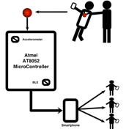

The device basically consists of the following components:

## ATMEL AT8052 Microcontroller

The board has various I/O connectors and also supports a varied number of programming language options including 8051 assembly and C. Using this board one can develop any 8052 40 pin structure of the micro-controller. It also supports different interfaces for various analog sensors. The ADC is also used to change the signals coming from the different modules to digital signals understood by the micro-controller.

## Accelerometer

This sensor uses a piezoelectric transducer. When the transducer is moved from a neutral axis, bending takes place which results in straining of the piezoelectric element thereby generating voltage. It consists of three -5 to +5g accelerometers to detect acceleration in all three dimensions, all placed on a single block. If appropriate data collection hardware and software is used then one can plot graphs of any of these components, or even calculate the net acceleration in all the there axes combined. This 3-Axis Accelerometer is being used for a a range of experiments and demonstrations. The size of the accelerometer being small helped us mount into our jewellery.

## Bluetooth Low Energy(BLE)

In comparison to Classic Bluetooth, Bluetooth Smart is being used today for the base purpose of using lower power and reduced cost but not compromising with its range.The protocol used in this device is not backward compatible with the previous Bluetooth protocol, often called as Classic Bluetooth Protocol.The LE and classic systems can be implemented by using the Bluetooth 4.0 .It uses the same frequency as its previous counterpart i.e. 2.4GHz, and also allows a single radio antenna to be shared amongst dual devices, but LE uses simpler modulations .

# Implementation

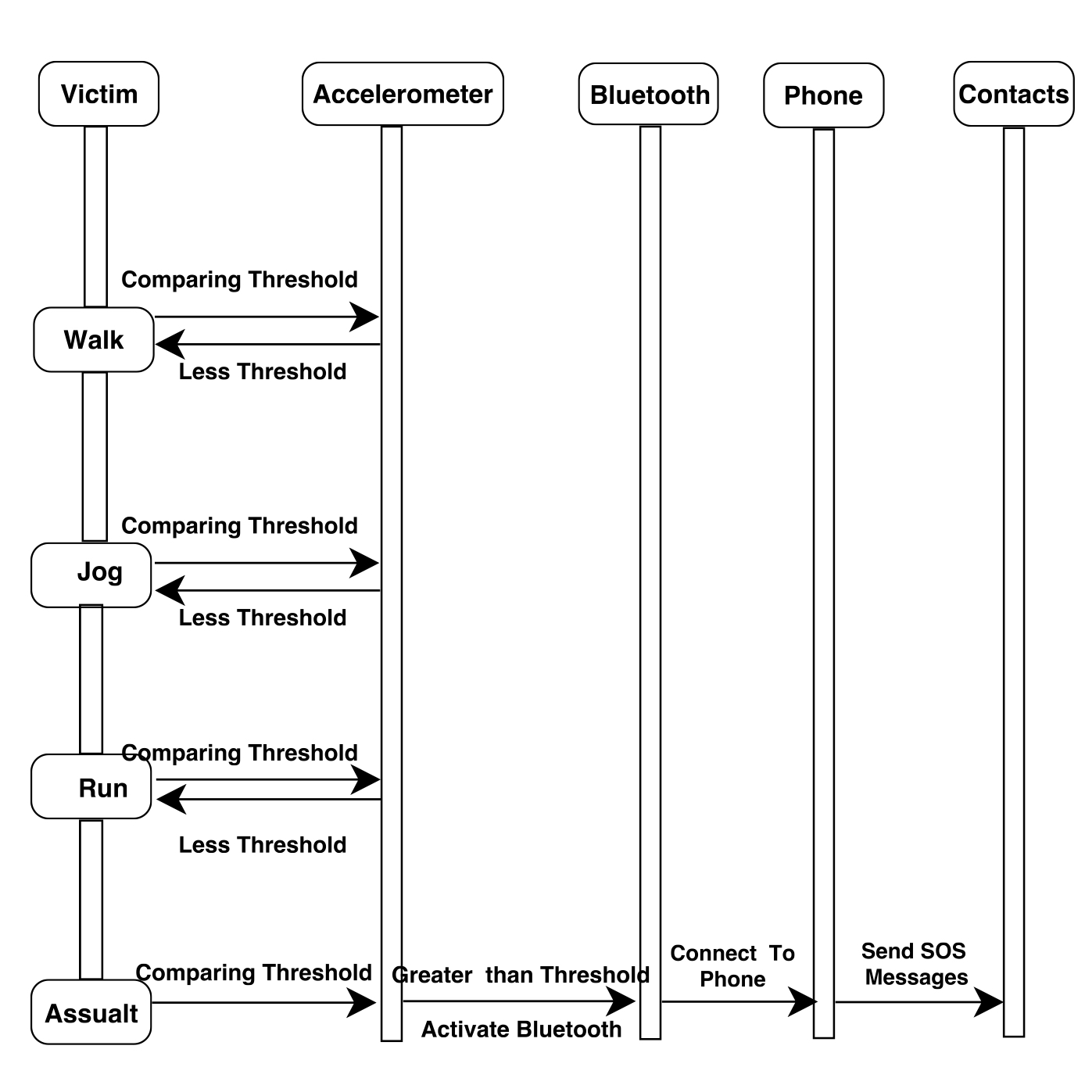The above figure can be used to explain the implementation credentials of our device. The microcontroller is the heart of our product, it governs the overall integrated functionality. The accelerometer senses the acceleration of the victim’s body at each moment. The different styles of movement like walking, jogging and running produce different accelerations. After careful amount of testing, a certain threshold was fixed and if it were reached then the action might be considered as an assault. The microcontroller keeps comparing the threshold to the accelerometer readings to support the dynamic functionality of our product. If the threshold is reached then it signals the BLE component to establish a secure connection with the victim’s smart phone. An application, built purely for the device, helps send SOS messages to the concerned personnel of the victim. While implementing our device we had to tackle some of the difficulties encountered. One of the biggest challenges faced in the initial of the implementation was to sample X, Y and Z coordinate points data to carry out tests on the accelerometer. As sampling data on microcontroller was not proving to be efficient enough, a mobile application was made to do the work in real time. Next difficulty was calculating threshold values, making the microcontroller differentiate between different motion gestures, such as running, jogging or walking and an assault was a real tough job. This was carried out by precise study of co-ordinates (X, Y and Z) to see the uniqueness that an assault holds. Further to carry out efficient serial communication between the modules, I2C protocol should deliver the required configuration which was a major challenge. This challenge was tackled by precise study of timing clocks and use of modules as well as to carry out efficient serial communication between the mobile phone and the device, BLE protocol should deliver the required configuration which was a major challenge. This challenge was tackled by precise study of stack protocols and BLE stack layers.

# Testing

For our device, testing is the most important phase because our device detects an assault based on the force of acceleration with which the person is pulled or pushed, called the threshold value. Hence a number of tests are performed for different use cases to enable us to understand the pattern as well as determine the threshold value. Testing needs to be extensive and is done in several steps to ensure each module of the device gives close to 100 percent accuracy.

## Unit Testing

### *Accelerometer Testing*

To understand the working of the accelerometer, as the first step we chose the phone’s accelerometer to analyze the data. Since we know there are 3 axes- x-axis,y-axis and z-axis, we started fetching the data for all three axes. To get a better understanding of the data and plotting graphs to differentiate between a walk, a run,jog and assault(push/pull) we designed an application. This data helped us to determine the threshold value required.

### *BLE Testing*

To test the BLE, we designed an application which connects to the BLE of the phone and sends SOS messages to the specified contacts within the application. This was done to test if the connection is done efficiently and successfully.

### *Microcontroller Testing*

Once the Accelerometer and BLE were tested, it was integrated along with the Atmel AT8052 microcontroller. After fetching the data we designed an algorithm to compare the accelerometer readings and the threshold value. We dumped this code into the microcontroller using the Willer Programmer.

## Integrated Testing

After the code was dumped using Willer Programmer into the microcontroller. The accelerometer and the BLE along with the battery were integrated together to test the working of the device. Similar tests regarding each component were done again, the accelerometer readings were compared and if it were reached, a connection was seen to be established between the device and the victim’s smart phone through the BLE. SOS messages were sent to the specified contact numbers.

## System Testing

After the integration testing, the software had been assembled as a package. Interfacing errors have been uncovered and corrected. The final series of software tests, hardware tests and validation tests begin. Validation test succeeds when the device functions in a manner that was expected. Here the system tested against System Requirements Specification. System testing was actually a series of different tests whose primary purpose was to fully exercise the computer-based system. Although each test has a different purpose, all work to verify that all system elements are properly integrated and perform satisfactorily.

# Conclusion

The phenomenon called technology has usurped people's imaginations in the last few decades. The ground breaking and cutting edge innovations in all aspects of Computer Science has truly given rise to a paradigm shift in technology. The field of wearable technologies has fascinated man for times immemorial and man has always dreamt of building a device which is intelligent enough to cater to his needs. ‘A world with wearable technologies that can provide for the protection of humans’, imagine how prosperous and advanced our civilization would appear. Thus this is just our humble attempt to realize the same dream at a much smaller scale. Thus this device would be capable of detecting assaults through real time motion recognition and informing the emergency contacts about their whereabouts.

Thus it is a device with capabilities to support man in field of safety. Extended functionalities integrated into the device would certainly make it all the more important and useful in human lives because we truly believe that such cognitive devices would certainly be at the heart of technology and human lives. Also if more and more resources are at our disposal in terms of both finance and man power, the device can be made even more versatile and can be made extremely intelligent and scalable.

# Acknowledgement

The work reported in this paper is supported the college through the TECHNICAL EDUCA TION QUALITY IMPROVEMENT PROGRAM [TEQUIP- II] of the MHRD, GOVERNMENT OF INDIA.

References

[1] Stephen Brewster, ― Multimodal 'eyes-free 'interaction techniques for wearable devices‖, 2003

[2] Steve Mann, Jason Nolan and Barry Wellman,‖ Sousveillance: Inventing and Using Wearable Computing Devices for Data Collection in Surveillance Environments.‖ 2003

[3] Sabri Khssibi, Hanen Idoudi, Adrien Van Den Bossche, Thierry Val and Leila Azzouz Saidane,‖ Presentation and

[4] Josie Hughes, Jize Yan and Kenichi Soga Cambridge University Engineering Department, Trumpington Street, Cambridge, CB2 1PZ, UK,‖ Development Of Wireless Sensor Network Using Bluetooth Low Energy (BLE) For Construction Noise Monitoring‖, June 1, 2015

[5] Akhilesh G. Naik Microelectronics, ETC Dept., Goa College of Engineering, Goa University, India,‖ Evaluation and Comparison of Classic Bluetooth and Bluetooth Low Energy (BLE) for Industrial Applications‖, 3 March 2015

[6] Alf Helge Omre, BTech–EEE, Nordic Semiconductor, Oslo, Norway, ―Bluetooth Low Energy: Wireless Connectivity for Medical Monitoring‖, March 1, 2010

[7] K.Gautham, G.Raghav, N.R.Raajan, Department of ECE, SEEE, SAST1RA University Thanjavur, Tamil Nadu, India,‖ Personnel Security System using Bluetooth Low Energy (BLE) Tag‖, May 2014

[8] Curone, Nudnik, Loriga and more,‖ Smart Garments for Safety Improvement of Emergency/Disaster Operators‖ Aug, 2007

[9] Activity Recognition using Cell Phone Accelerometers Published by: Jennifer R. Kwapisz, Gary M. Weiss, Samuel A. Moore Department of Computer and Information Science, Fordham University.

[10] Premkumar, CibiChakkaravarthi, Keerthana, Ravivarma, Sharmila, One Touch Alarm System For Women’s Safety Using GSM , 01, March 2015, Volume No. 04.

[11] Remya George, Anjaly Cherian.V, Annet Antony, Harsha Sebestian, Mishal Antony, Rosemary Babu.T,‖ An Intelligent Security System for Violence against Women in Public Places‖, April 2014 Volume-3, Issue-4. ISSN: 2249 – 8958 (IJEAT)

[12] Mr.Magesh Kumar, Mr.Raj Kumar, IPROB – ―Emergency Application For Women‖, March 2014. Volume 4, Issue 3. ISSN: 2250-3153

[13] Che-Chang Yang and Yeh-Liang Hsudoi ―A Review of Accelerometry-Based Wearable Motion Detectors for Physical Activity Monitoring‖, 2010 Aug 20, 10.3390/s100807772 PMCID: PMC323118

[14] Kumar Kandukuri, A. Amala Jency, R. Anita, K.S. Pavithra, V. Seema, ―Android Based Women Safety Application with Blood Pressure, Heart Beat Monitoring and Location Tracking, Emergency Support System‖, IJSRD - International Journal for Scientific Research & Development| Vol. 3, Issue 01, 201

[15] Jennifer R. Kwapisz, Gary M. Weiss, Samuel A. Moore, ―Activity Recognition using Cell Phone Accelerometers‖, Department of Computer and Information Science Fordham University

[16] Nishant Bhardwaj and Nitish Aggarwal, Design and Development of ―Suraksha‖-A Women Safety Device, International Journal of Information & Computation Technology. ISSN 0974-2239 Volume 4, Number 8 (2014).

[17] ―New Directions in Jewelry‖: a Close Look at Emerging Trends & Developments in Jewelry-like Wearable Devices Yulia Silina, Hamed Haddadi Cognitive Science Research Group Queen Mary University of London, UK

[18] Chen KY, Bassett DR., and Jr The technology of accelerometry-based activity monitors: Current and future.Med. Sci. Sports. Exerc. 2005; 37:490–500.

[19] Mathie MJ, Coster ACF, Lovell NH, and Celler BG. Accelerometry: providing an integrated, practical method for long- term, ambulatory monitoring of human movement. Physiol. Meas. 2004; 25:1–20.

[20] Morris JRW. Accelerometry—A technique for the measurement of human body movement. J. Biomech.1973; 6:729–736

[21] Godfrey A, Conway R, Meagher D, ÓLaighin G. Direct measurement of human movement by accelerometry. Med. Eng. Phys. 2008; 30:1364–1386

[22] Karantonis DM, Narayanan MR, Mathie M, Lovell NH, Celler BG. Implementation of a real-time human movement classifier using a triaxial accelerometer for ambulatory monitoring. IEEE. Trans. Inf. Technol. Biomed. 2006; 10:156– 167.

[23] Sabri Khssibi, Hanen Idoudi, Adrien Van Den Bossche, Thierry Val and Leila Azzouz Saidane, Presentation and analysis of a new technology for low-power wireless sensor network International Journal of Digital Information and Wireless Communications (IJDIWC) 3(1): 81-92,The Society of Digital Information and Wireless Communications, 2013 (ISSN: 2225-658X).

[24] ―Introduction to Nordic nRF51822‖ URL: ―https://www.nordicsemi.com/eng/Products/Bluetooth- Smart.../nRF51822‖

[25] ―Development Tools for Nordic nRF51822‖ URL: ―https://www.nordicsemi.com/eng/Products/Bluetooth-Smart- Bluetooth-low-energy/nRF51822‖

1.